Statistik Heimatmuseum Laab 2010

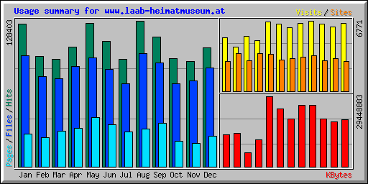

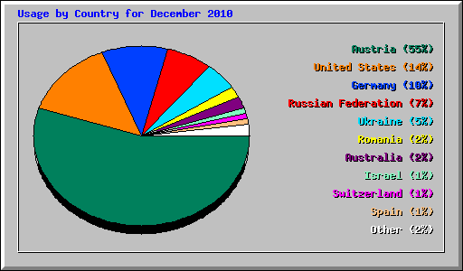
Diese Staaten klicken das Heimatmuseum Laab

1 | 47510 | 53.05% | 39056 | 52.24% | 7312309 | 41.39% | Austria
2 | 13223 | 14.77% | 9806 | 13.12% | 732638 | 4.15% | United States
3 | 9093 | 10.15% | 8336 | 11.15% | 847919 | 4.80% | Germany
4 | 5885 | 6.57% | 5406 | 7.23% | 250981 | 1.42% | Russian Federation
5 | 4952 | 5.53% | 4624 | 6.18% | 6733146 | 38.11% | Ukraine
6 | 2442 | 2.73% | 2419 | 3.24% | 1062 | 0.01% | Romania
7 | 1761 | 1.97% | 1642 | 2.20% | 1267490 | 7.17% | Australia
8 | 1206 | 1.35% | 1157 | 1.55% | 103283 | 0.58% | Israel
9 | 876 | 0.98% | 821 | 1.10% | 13952 | 0.08% | Switzerland
10 | 524 | 0.59% | 516 | 0.69% | 11289 | 0.06% | Spain
11 | 423 | 0.47% | 369 | 0.49% | 7933 | 0.04% | France
12 | 364 | 0.41% | 359 | 0.48% | 165689 | 0.94% | Netherlands
13 | 214 | 0.24% | 209 | 0.28% | 13677 | 0.08% | Unresolved/Unknown
14 | 177 | 0.20% | 124 | 0.17% | 2255 | 0.01% | Sweden
15 | 164 | 0.18% | 126 | 0.17% | 2032 | 0.01% | Italy
16 | 70 | 0.08% | 66 | 0.09% | 2035 | 0.01% | Latvia
17 | 69 | 0.08% | 66 | 0.09% | 186274 | 1.05% | Hungary
18 | 62 | 0.07% | 58 | 0.08% | 2239 | 0.01% | Poland
19 | 52 | 0.06% | 51 | 0.07% | 1479 | 0.01% | Brazil
20 | 42 | 0.05% | 35 | 0.05% | 525 | 0.00% | Great Britain (UK)
21 | 42 | 0.05% | 39 | 0.05% | 652 | 0.00% | Slovakia
22 | 40 | 0.04% | 38 | 0.05% | 453 | 0.00% | Denmark
23 | 30 | 0.03% | 26 | 0.03% | 1003 | 0.01% | Belgium
24 | 29 | 0.03% | 29 | 0.04% | 496 | 0.00% | Luxembourg
25 | 29 | 0.03% | 27 | 0.04% | 312 | 0.00% | Turkey
26 | 28 | 0.03% | 27 | 0.04% | 1068 | 0.01% | Estonia
27 | 27 | 0.03% | 17 | 0.02% | 262 | 0.00% | Ireland
28 | 25 | 0.03% | 18 | 0.02% | 588 | 0.00% | Canada
29 | 19 | 0.02% | 19 | 0.03% | 223 | 0.00% | Czech Republic
30 | 19 | 0.02% | 18 | 0.02% | 182 | 0.00% | Norway

Generated by Webalizer Version 2.21

